SEC Form 4
FORM 4 |  | UNITED STATES SECURITIES AND EXCHANGE COMMISSION  Washington, D.C. 20549  STATEMENT OF CHANGES IN BENEFICIAL OWNERSHIP  Filed pursuant to Section 16(a) of the Securities Exchange Act of 1934  or Section 30(h) of the Investment Company Act of 1940
  OMB APPROVAL
  OMB Number: | 3235-0287
  Estimated average burden
  hours per response: | 0.5
 | Check this box if no longer subject to Section 16. Form 4 or Form 5 obligations may continue. See Instruction 1(b).
 | Check this box to indicate that a transaction was made pursuant to a contract, instruction or written plan for the purchase or sale of equity securities of the issuer that is intended to satisfy the affirmative defense conditions of Rule 10b5-1(c). See Instruction 10.
1. Name and Address of Reporting Person*  (Street) | 2. Issuer Name and Ticker or Trading Symbol  EVgo Inc. [ EVGO ]  Foreign Trading Symbol | 5. Relationship of Reporting Person(s) to Issuer  (Check all applicable)
  Scott Amber
  (Last) | (First) | (Middle)
  C/O EVGO INC.
  1661 EAST FRANKLIN AVENUE
  EL SEGUNDO | CA | 90245
  (City) | (State) | (Zip)
   | Director |  | 10% Owner
   | Officer (give title below) |  | Other (specify below)
  Chief Accounting Officer
3. Date of Earliest Transaction (Month/Day/Year)
09/25/2026
 | 4. If Amendment, Date of Original Filed (Month/Day/Year) | 6. Individual or Joint/Group Filing (Check Applicable Line)
  Form filed by One Reporting Person
  Form filed by More than One Reporting Person
Table I - Non-Derivative Securities Acquired, Disposed of, or Beneficially Owned
1. Title of Security (Instr. 3) | 2. Transaction Date (Month/Day/Year) | 2A. Deemed Execution Date, if any (Month/Day/Year) | 3. Transaction Code (Instr. 8) |  | 4. Securities Acquired (A) or Disposed Of (D) (Instr. 3, 4 and 5) |  |  | 5. Amount of Securities Beneficially Owned Following Reported Transaction(s) (Instr. 3 and 4) | 6. Ownership Form: Direct (D) or Indirect (I) (Instr. 4) | 7. Nature of Indirect Beneficial Ownership (Instr. 4)
1. Title of Security (Instr. 3) | 2. Transaction Date (Month/Day/Year) | 2A. Deemed Execution Date, if any (Month/Day/Year) | Code | V | Amount | (A) or (D) | Price |  | 6. Ownership Form: Direct (D) or Indirect (I) (Instr. 4) | 7. Nature of Indirect Beneficial Ownership (Instr. 4)
Table II - Derivative Securities Acquired, Disposed of, or Beneficially Owned
(e.g., puts, calls, warrants, options, convertible securities)
1. Title of Derivative Security (Instr. 3) | 2. Conversion or Exercise Price of Derivative Security | 3. Transaction Date (Month/Day/Year) | 3A. Deemed Execution Date, if any (Month/Day/Year) | 4. Transaction Code (Instr. 8) |  | 5. Number of Derivative Securities Acquired (A) or Disposed of (D) (Instr. 3, 4 and 5) |  | 6. Date Exercisable and Expiration Date (Month/Day/Year) |  | 7. Title and Amount of Securities Underlying Derivative Security (Instr. 3 and 4) |  | 8. Price of Derivative Security (Instr. 5) | 9. Number of derivative Securities Beneficially Owned Following Reported Transaction(s) (Instr. 4) | 10. Ownership Form: Direct (D) or Indirect (I) (Instr. 4) | 11. Nature of Indirect Beneficial Ownership (Instr. 4)
 |  |  |  | Code | V | (A) | (D) | Date Exercisable | Expiration Date | Title | Amount or Number of Shares
Restricted Stock Units | (1) | 09/25/2026 |  | A |  | 173,267 |  | (2) | (2) | Class A Common Stock | 173,267 | $0 | 173,267 | D
Restricted Stock Units | (1) | 09/25/2026 |  | A |  | 136,139 |  | (3) | (3) | Class A Common Stock | 136,139 | $0 | 136,139 | D
Explanation of Responses:
1. Restricted stock units ("RSUs") awarded under the Issuer's 2021 Long Term Incentive Plan (the "Plan"). Each RSU represents the contingent right to receive, upon vesting of the RSU, one share of the Issuer's Class A common stock, $0.0001 par value ("Class A Common Stock").
2. One-half of the RSUs subject to the award shall vest on the one-year anniversary of the July 1, 2026 (the "Vesting Commencement Date") and the remaining one-half of the RSUs subject to the award shall vest on the two-year anniversary of the Vesting Commencement Date, such that the award shall be fully vested on July 1, 2028, in each case subject to the Reporting Person's continued employment through each vesting date.
3. One-third of the RSUs subject to the award shall vest on the one-year anniversary of July 1, 2026 and the remaining two-thirds of the RSUs subject to the award shall vest in eight substantially equal tranches on October 1, January 1, April 1 and July 1 thereafter, such that each award shall be fully vested on July 1, 2029, in each case subject to the Reporting Person's continued employment through each vesting date.
Remarks:
Exhibit 24 - Power of Attorney
 | /s/ Amber Scott, by Francine Sullivan, as Attorney-in-Fact | 09/29/2026
 | ** Signature of Reporting Person | Date
Reminder: Report on a separate line for each class of securities beneficially owned directly or indirectly.
* If the form is filed by more than one reporting person, see Instruction 4 (b)(v).
** Intentional misstatements or omissions of facts constitute Federal Criminal Violations See 18 U.S.C. 1001 and 15 U.S.C. 78ff(a).
Note: File three copies of this Form, one of which must be manually signed. If space is insufficient, see Instruction 6 for procedure.
Persons who respond to the collection of information contained in this form are not required to respond unless the form displays a currently valid OMB Number.
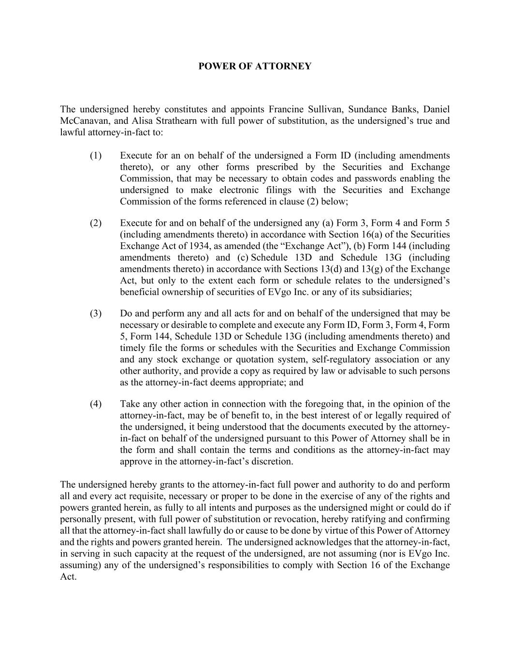
POWER OF ATTORNEY The undersigned hereby constitutes and appoints Francine Sullivan, Sundance Banks, Daniel McCanavan, and Alisa Strathearn with full power of substitution, as the undersigned’s true and lawful attorney-in-fact to: (1) Execute for an on behalf of the undersigned a Form ID (including amendments thereto), or any other forms prescribed by the Securities and Exchange Commission, that may be necessary to obtain codes and passwords enabling the undersigned to make electronic filings with the Securities and Exchange Commission of the forms referenced in clause (2) below; (2) Execute for and on behalf of the undersigned any (a) Form 3, Form 4 and Form 5 (including amendments thereto) in accordance with Section 16(a) of the Securities Exchange Act of 1934, as amended (the “Exchange Act”), (b) Form 144 (including amendments thereto) and (c) Schedule 13D and Schedule 13G (including amendments thereto) in accordance with Sections 13(d) and 13(g) of the Exchange Act, but only to the extent each form or schedule relates to the undersigned’s beneficial ownership of securities of EVgo Inc. or any of its subsidiaries; (3) Do and perform any and all acts for and on behalf of the undersigned that may be necessary or desirable to complete and execute any Form ID, Form 3, Form 4, Form 5, Form 144, Schedule 13D or Schedule 13G (including amendments thereto) and timely file the forms or schedules with the Securities and Exchange Commission and any stock exchange or quotation system, self-regulatory association or any other authority, and provide a copy as required by law or advisable to such persons as the attorney-in-fact deems appropriate; and (4) Take any other action in connection with the foregoing that, in the opinion of the attorney-in-fact, may be of benefit to, in the best interest of or legally required of the undersigned, it being understood that the documents executed by the attorney- in-fact on behalf of the undersigned pursuant to this Power of Attorney shall be in the form and shall contain the terms and conditions as the attorney-in-fact may approve in the attorney-in-fact’s discretion. The undersigned hereby grants to the attorney-in-fact full power and authority to do and perform all and every act requisite, necessary or proper to be done in the exercise of any of the rights and powers granted herein, as fully to all intents and purposes as the undersigned might or could do if personally present, with full power of substitution or revocation, hereby ratifying and confirming all that the attorney-in-fact shall lawfully do or cause to be done by virtue of this Power of Attorney and the rights and powers granted herein. The undersigned acknowledges that the attorney-in-fact, in serving in such capacity at the request of the undersigned, are not assuming (nor is EVgo Inc. assuming) any of the undersigned’s responsibilities to comply with Section 16 of the Exchange Act.

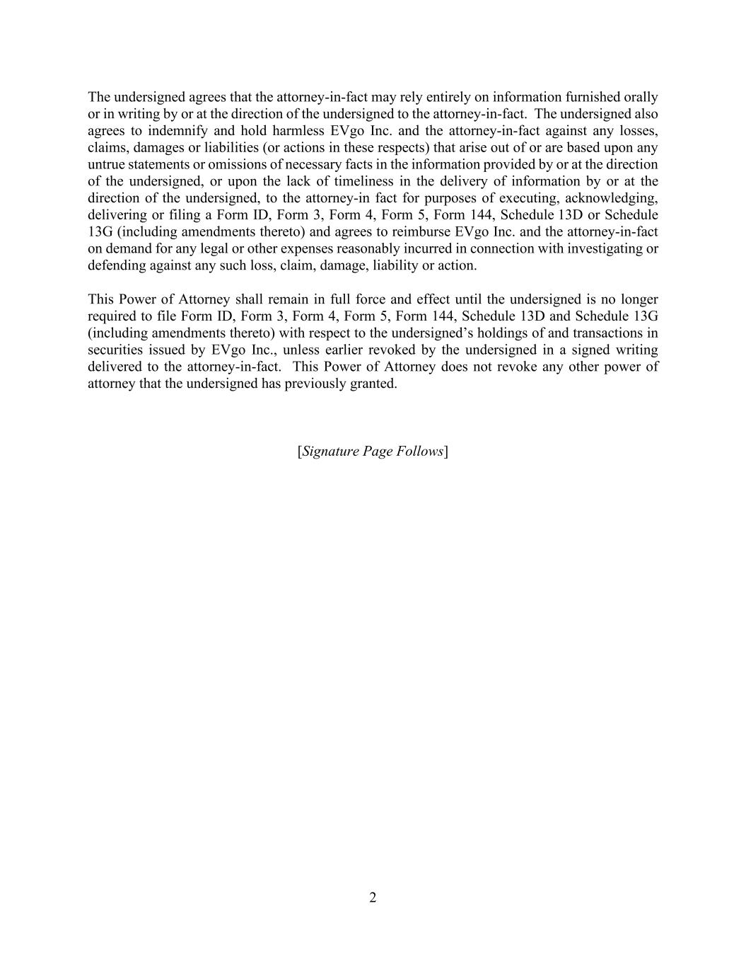
2 The undersigned agrees that the attorney-in-fact may rely entirely on information furnished orally or in writing by or at the direction of the undersigned to the attorney-in-fact. The undersigned also agrees to indemnify and hold harmless EVgo Inc. and the attorney-in-fact against any losses, claims, damages or liabilities (or actions in these respects) that arise out of or are based upon any untrue statements or omissions of necessary facts in the information provided by or at the direction of the undersigned, or upon the lack of timeliness in the delivery of information by or at the direction of the undersigned, to the attorney-in fact for purposes of executing, acknowledging, delivering or filing a Form ID, Form 3, Form 4, Form 5, Form 144, Schedule 13D or Schedule 13G (including amendments thereto) and agrees to reimburse EVgo Inc. and the attorney-in-fact on demand for any legal or other expenses reasonably incurred in connection with investigating or defending against any such loss, claim, damage, liability or action. This Power of Attorney shall remain in full force and effect until the undersigned is no longer required to file Form ID, Form 3, Form 4, Form 5, Form 144, Schedule 13D and Schedule 13G (including amendments thereto) with respect to the undersigned’s holdings of and transactions in securities issued by EVgo Inc., unless earlier revoked by the undersigned in a signed writing delivered to the attorney-in-fact. This Power of Attorney does not revoke any other power of attorney that the undersigned has previously granted. [Signature Page Follows]

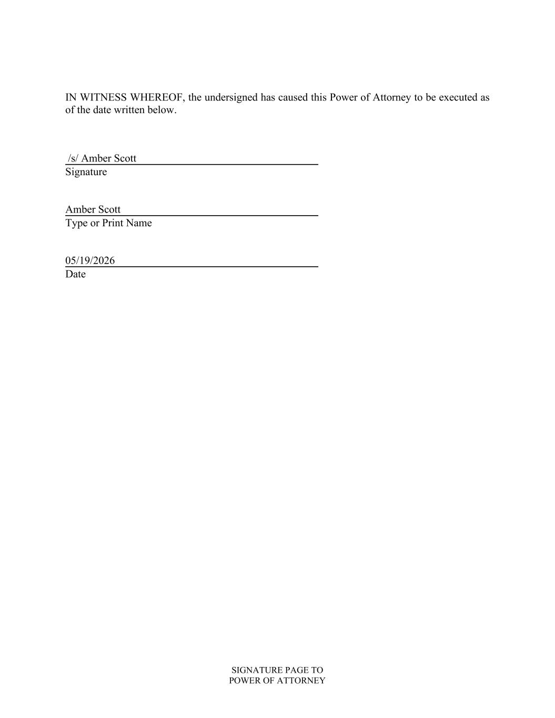
SIGNATURE PAGE TO POWER OF ATTORNEY IN WITNESS WHEREOF, the undersigned has caused this Power of Attorney to be executed as of the date written below. /s/ Amber Scott Signature Amber Scott Type or Print Name 05/19/2026 Date

